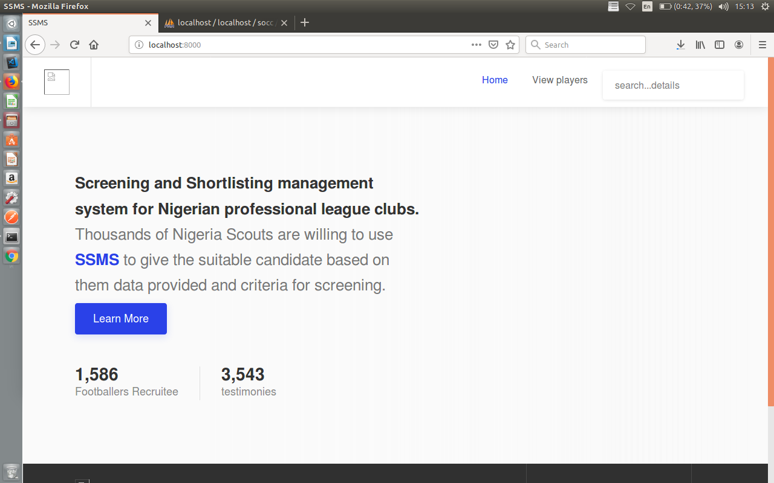
The indexpage the url is localhost:8000

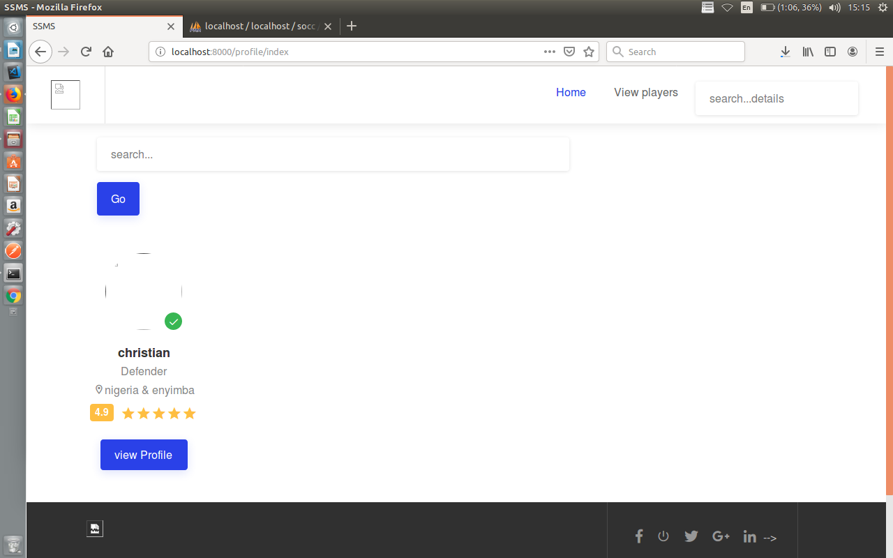
the view player page the url is profile/index
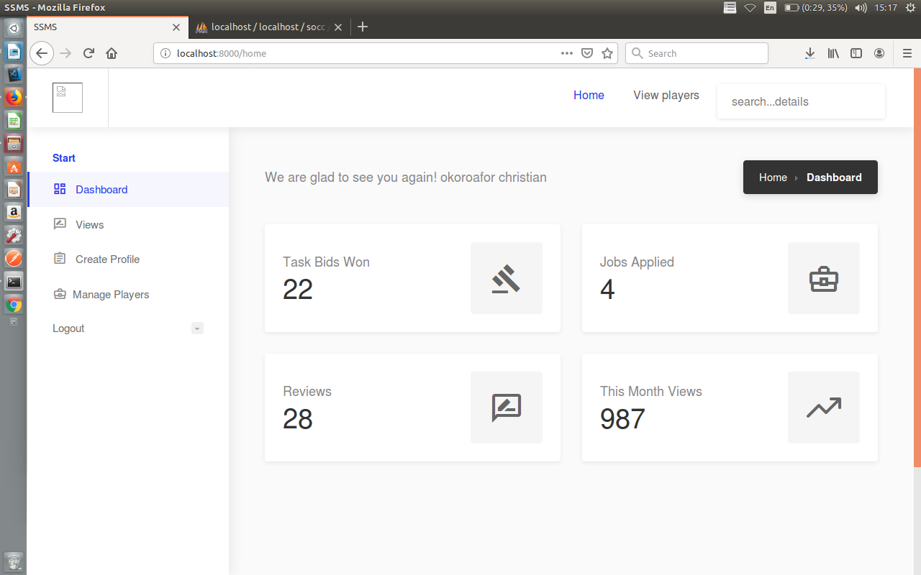
users dashboard this for the admin the url is localhost:8000/home\
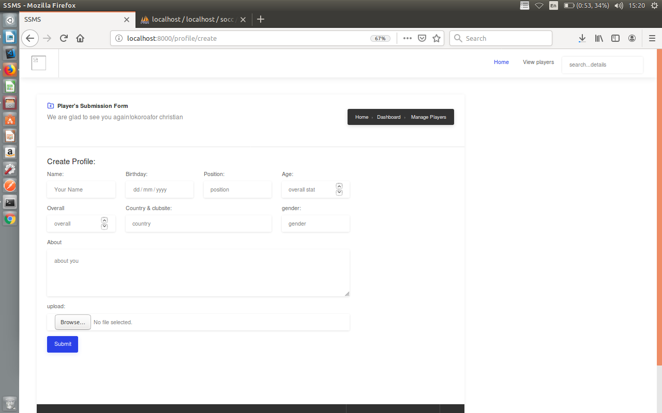

this is for creating players profile and the url is localhost:8000/profile/create

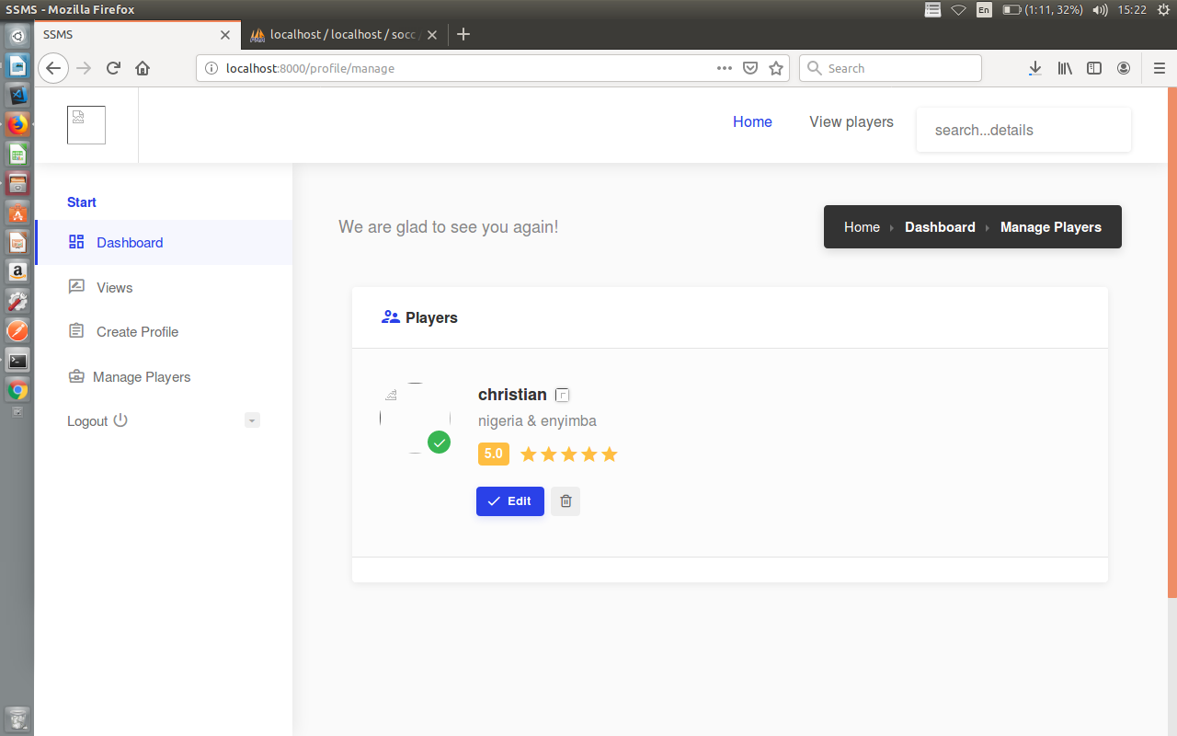
this is the manage players section the url is localhost:8000/profile/mange

